Pinelands Music School

Web Development Rundown



## Document Summary

This document contains a summary of developmental and technical aspects of the Pinelands Music School website over the course of Sprint 1 and Sprint 2.

Technical:

Software:

* Functionality: PHP and JavaScript
* Markup: HTMLs
* Styling: CSS
* Testing: Selenium

Server Specifications:

* Google cloud services – Virtual machine with Debian
* Apache2 Server
* MySQL Database
* PHPmyadmin Database Management

Base Requirements

Teachers:

•Edit profile

•Manage students enrollment

Admin:

•Create Teachers accounts

•Reports for various business activities and statistics

•Manage database data

Students:

•Enrollment

•Instrument hire

•Profile

•Class timetable

Technology Used

Hosting on google cloud services:  
 •Virtual Linux machine running debian  
 •Automatic scaling  
 •Pay for what you use  
 •Guaranteed 99.7% uptime

Languages:  
 •PHP & JS for functionality  
 •HTML for markup  
 •CSS for styling

Testing:  
 •Selenium IDE  
  
Infrastructure:

•Apache2  
 •mySQL for database  
 •PHPmyadmin for database management

Logo and Colour Design

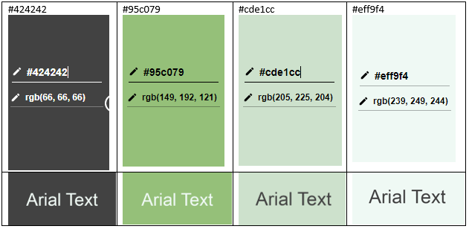

Site Architecture

Header, Footer, Nav Bars, etc… All **referenced** from one template.

* **Why** structure it like this?
  + Quick and easy to alter a large number of pages at once.
* Does this mean all pages will have the **same** Header, Footer, Nav Bar?
  + **No**! Any page can reference a unique template/header.
  + Example: Student/Teacher Portals

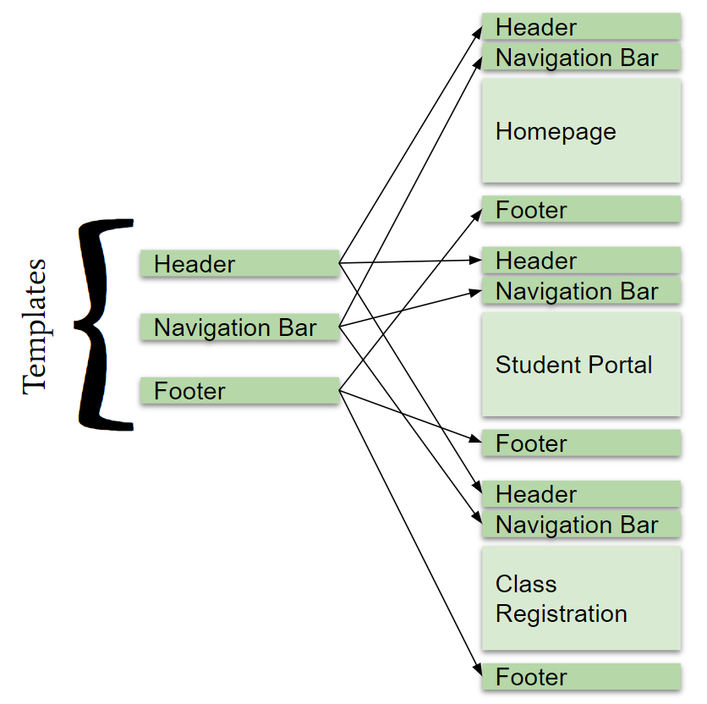

Hi-Fidelity Pages Notes:

Student edits profile:

* Page for editing details if they are ever changed such as (address or phone number)
* Database is updated upon submission

Admin views instrument log:

* Colour coded depending on state (red for overdue, green for available)

Admin views feedback:

* Feedback from students
* Visible only to the admin

Admin views/manages contracts:

* Admin can see details of their teachers’ contracts with students
* Option to edit terminate or add new contract
* Visible only to the admin

Database Structure: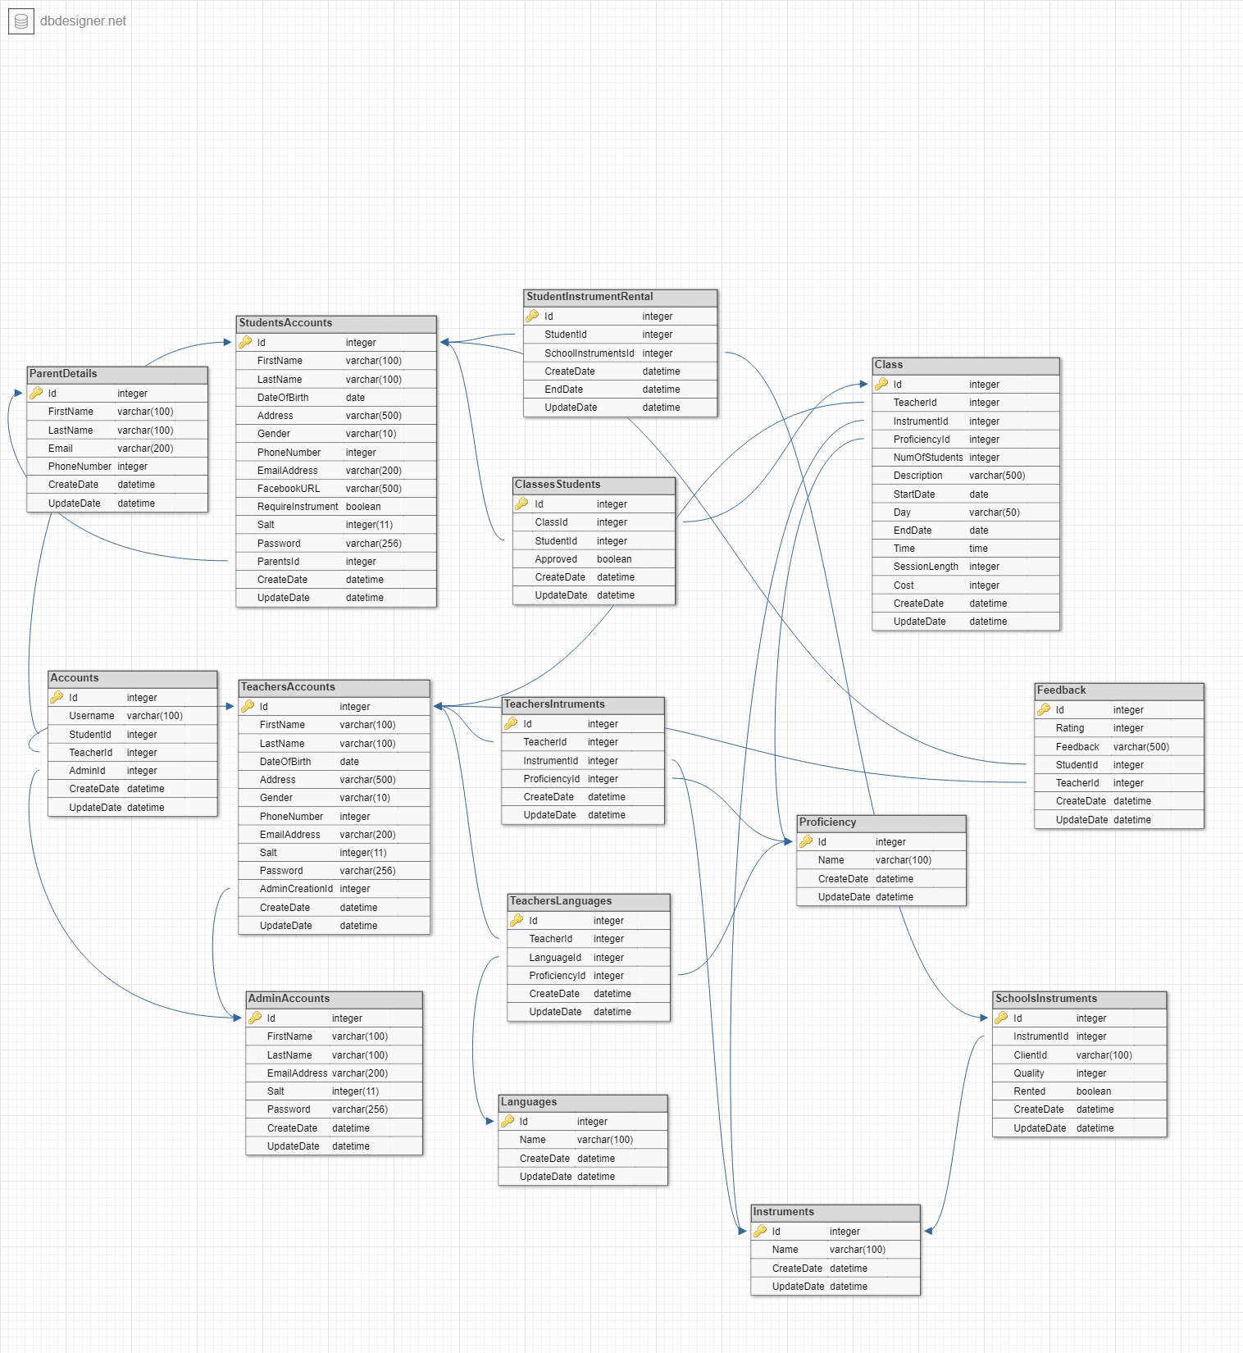

The image above shows the database and the connectivity of the tables within the database. As this is a complicated design the database is broken into the user groups admins, teachers and students.

Database Structure - Admins:

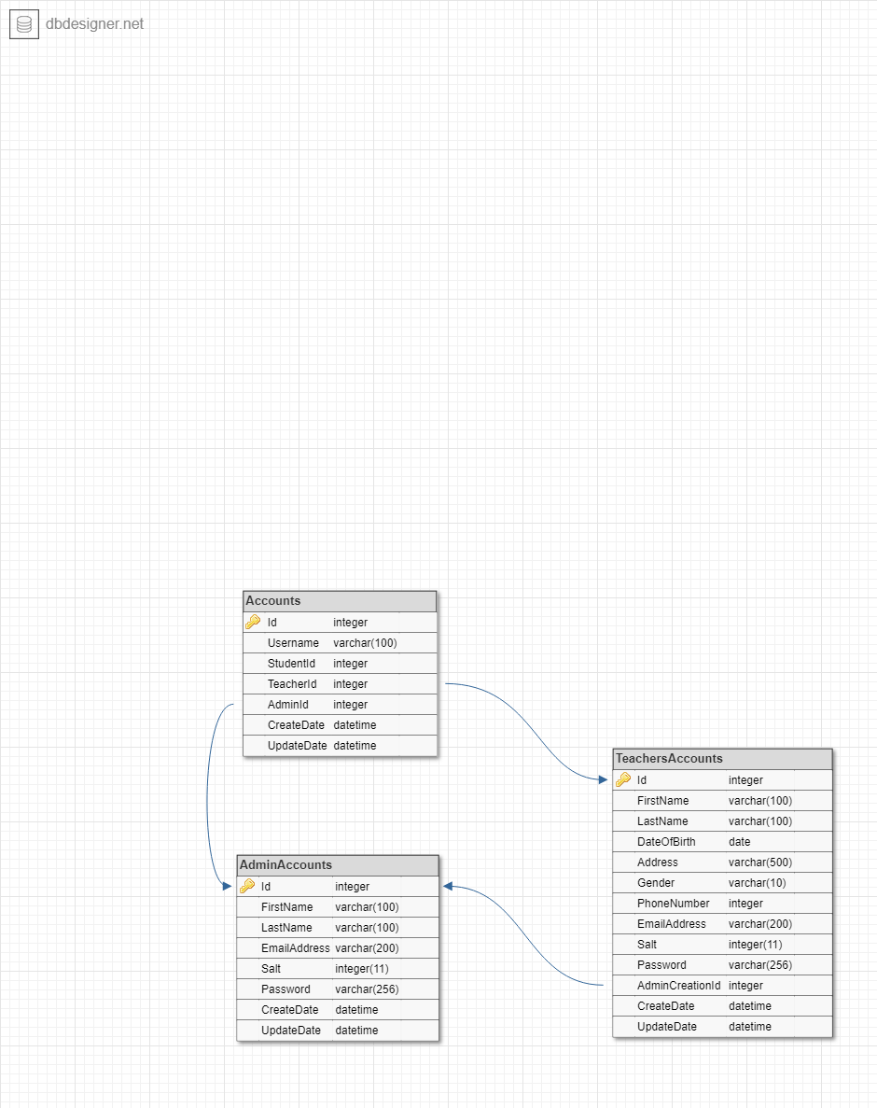

Database Structure - Teachers:

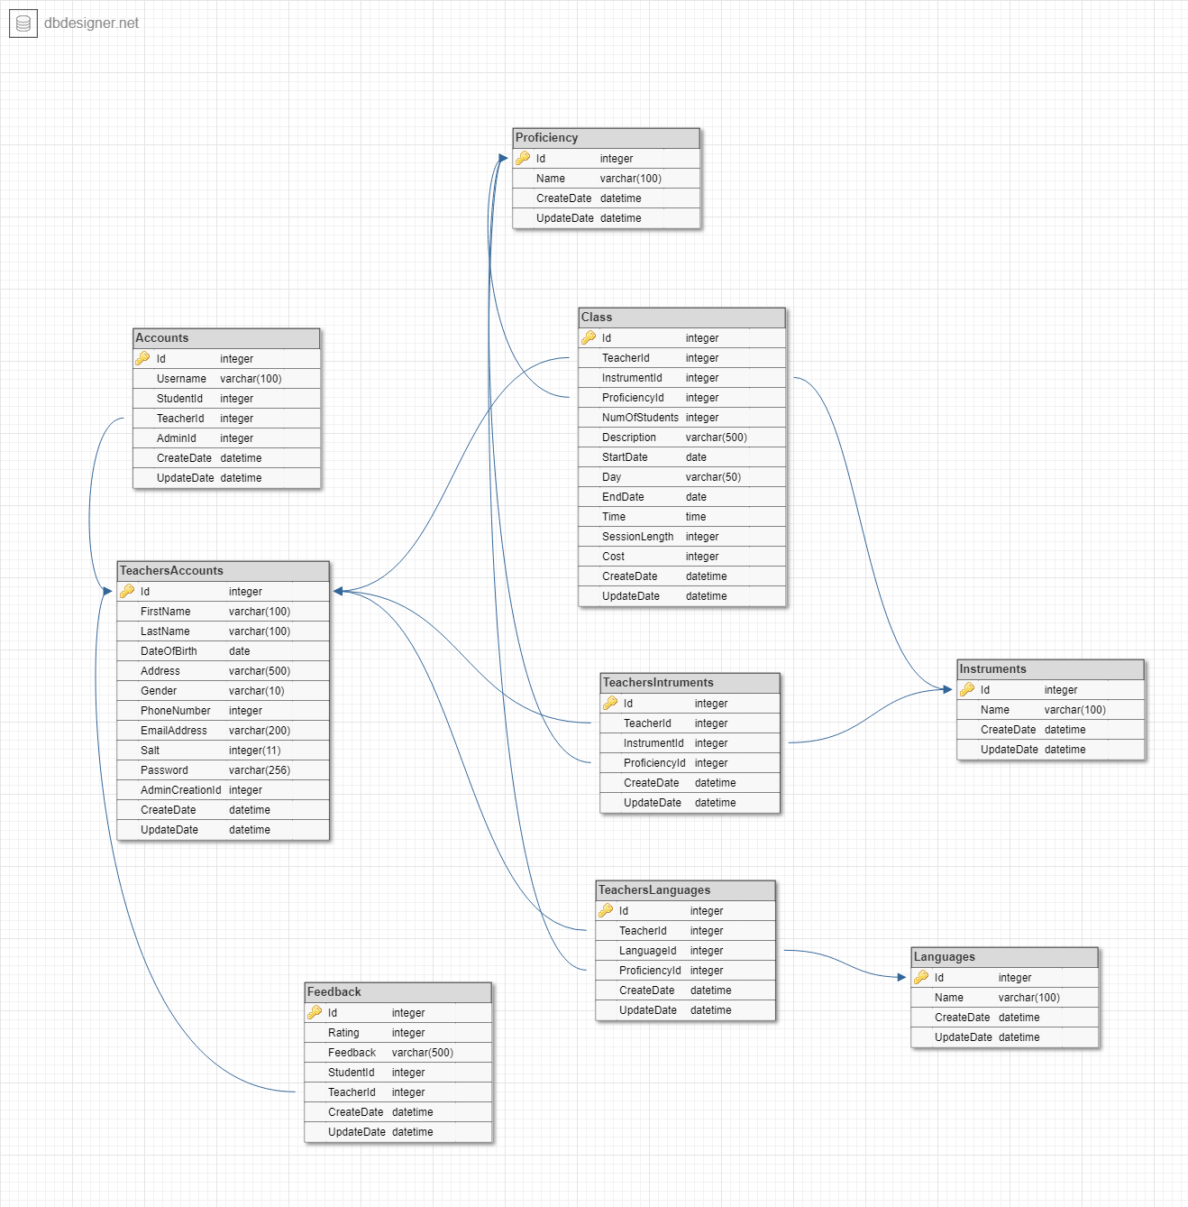

Database Structure - Students:

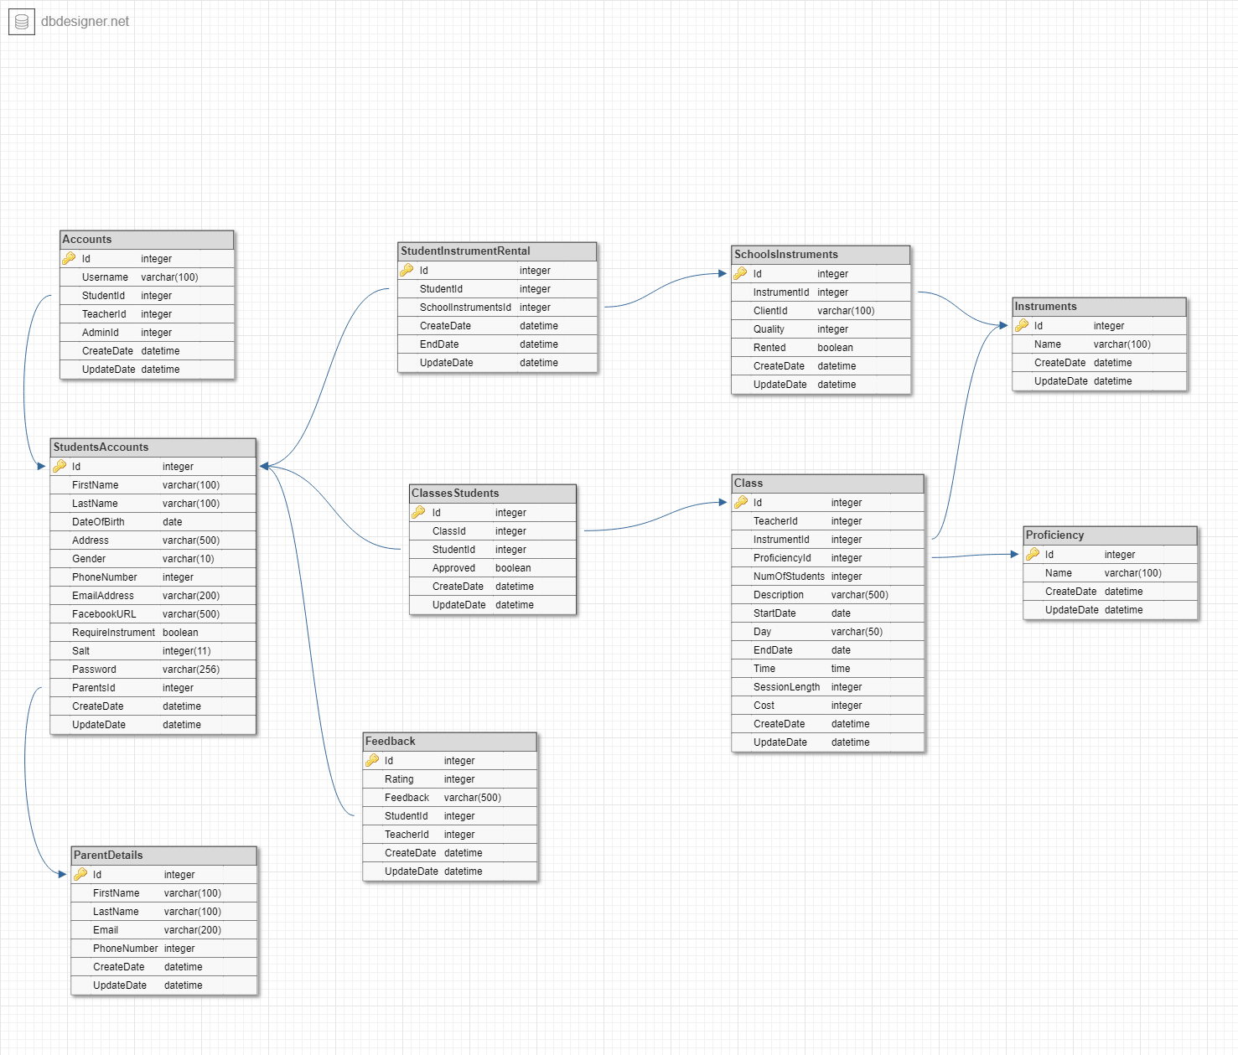

Business Plan Model:

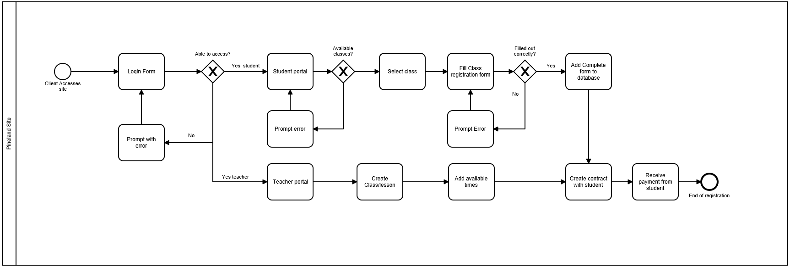

Test Procedures:

•Live website up and running

•Navigate through front pages

•Login and logout functionality  
 -Successful Login  
 -Show javascript for invalid entries  
 -Passwords entered are blocked out with a dot/asterisk

•Registration  
 -Warning messages for empty fields

•Students and teachers can navigate through their respectives tabs after logging in

•Private URL access for student, teacher and admin pages

## Sprint Documentation:

Burndown Charts

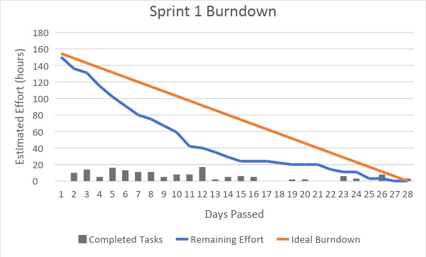

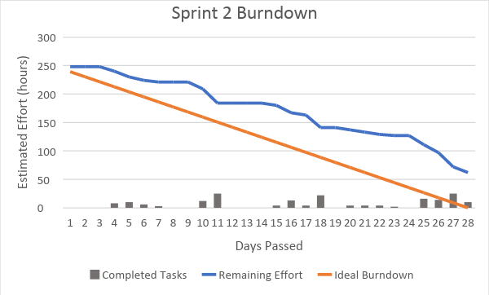

Git commit history

